Investigation of traveling acoustic waves with digital holography
Pascal Picart
Université du Maine, CNRS UMR 6613, LAUM, Avenue Olivier Messiaen, 72085 Le Mans Cedex 9, France
ENSIM, Ecole Nationale Supérieure d’Ingénieurs du Mans, rue Aristote, 72085 Le Mans, cedex 09, France
pascal.picart@univ-lemans.fr

Abstract—This paper describes recent advances in high-speed holographic imaging; especially we focus on the use of such an approach to investigate traveling acoustic waves. Special attention considers the case of waves propagating after a shock and in an acoustic black hole.
Index Terms—digital holography, phase imaging, acoustic waves, acoustic black hole

Introduction
In the domains of acoustics, vibro-acoustics, vibrations of structures or flow-induced vibrations, Laser Doppler Vibrometer (LDV) is the most favorite instrument for dynamics measurements [1-4]. To get simultaneously a collection of data points at the surface of the inspected vibrating object, multipoint vibrometer were developed [5-9]. Full-field evaluation can be obtained with digital holography interferometry. Such an approach is well suited because of the high density of measuring points and the reduced measurement time. The use of time-averaging and quasi-time-averaging in digital Fresnel holography was proposed and discussed in the past [10]. However, the stationary regime is a particular case for investigating the structure vibration behavior (propagation of travelling waves), and the characterization of structures under operational or real functioning conditions requires analysis in the time domain. Then, providing a real-time follow-up of the vibration amplitude, whatever the excitation condition is a challenge for full-field optical metrology. As examples, problems that cannot be addressed by a stationary approach are: vibrations of panels induced by hydro or aero-acoustic sources, structural vibration induced by squeak and rattle noise. Performances of high power continuous wave lasers (>6W) and high-speed CMOS sensors (rate up to 1MHz) have been improved significantly these past years. Such technologies give opportunity of merging holographic interferometry and vibration analysis to develop an adapted approach for a real-time and multi-point recording of transient phenomena. Since the holograms are recorded with a high-speed matrix sensor, the real-time recording of transient phenomena, at their time-scale evolution, is made possible. The proposed approach is then not limited to stationary phenomena.
So, this paper describes recent advances in high-speed holographic imaging; especially we focus on the use of such an approach to investigate traveling acoustic waves. Special attention considers the case of waves propagating after a shock and in an acoustic black hole (ABH).

Experimental set-up
The experimental set-up is described in Fig. 1 [11].
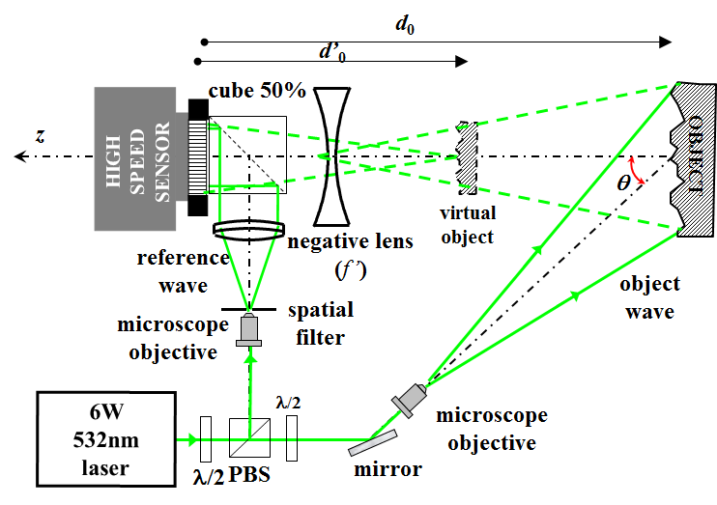
- Experimental set-up
The light source is from a DPSS laser at λ=532nm with maximum power at 6W. The sensor is a high speed camera (Photron) with pixel 20μm and a maximum spatial resolution M×N=1024×1024 pixels. A full spatial resolution, the maximum frequency is 13500Hz. By increasing the rate, spatial resolution is degraded. The exposure time can be set from 380ns to few μs. The main advantage of high speed digital holography is that a travelling acoustic wave propagating in a structure can be measured with a high density of measuring points. Examples are given in the next section.

Investigation of travelling waves

Visualization of impact point
The first example deals with the determination of the impact point. A structure is impacted by a hammer on its back (ie not visible). High-speed holographic recording leads to the visualization of the shock wave propagating in the structure. The recording parameters for this measurement are a frame rate at 72kHz, spatial resolution at M×N=384×384 pixels, with an exposure time T=5μs. A hologram sequence is recorded with more than 36,000 images, corresponding to a time window of 0.5s. Figure 2 shows modulo 2π phase maps extracted from the sequence, showing the mechanical wave front emitted at the impact point, and propagating along the plate. The point of impact can be clearly located. The impact point is at the curvature center of the spherical wave. The spherical wave front propagates in the measured area. The delay between each map is approx. 14μs.

Visualization of impact point
A second application deals with the visualization of transient acoustic waves propagating in complex structures, and excited by a transient signal. The object is an aluminum beam 89.5cm×0.2cm×2cm suspended at one of its ends, and excited by a mechanical agitator in the center. This beam is equipped with an ABH. The excitation signal has a bandwidth 20Hz-10kHz. The illuminating laser wave is shaped to produce a uniform rectangular illumination of 10cm×2cm from the bottom of the beam. Extraction of the reconstructed hologram phases leads to the viewing of the acoustic wave front. Figure 3 shows series of phase images extracted from a sequence of holograms recorded at 60kHz. The propagation of a travelling acoustic wave front can be observed in the beam equipped with the ABH. A plane wave front is observed and propagates to ABH termination, then it turns into transverse waves. The method therefore makes it possible to visualize the mode conversion at the end of the ABH.
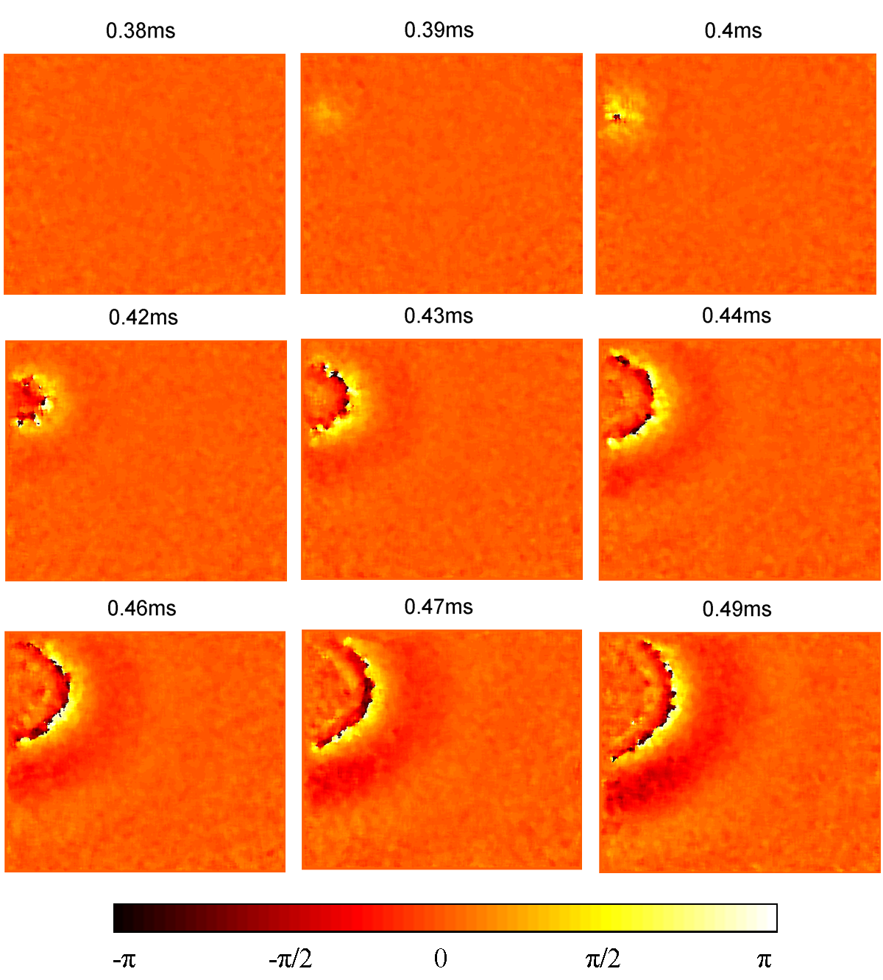
- Travelling wave emitted at the impact point
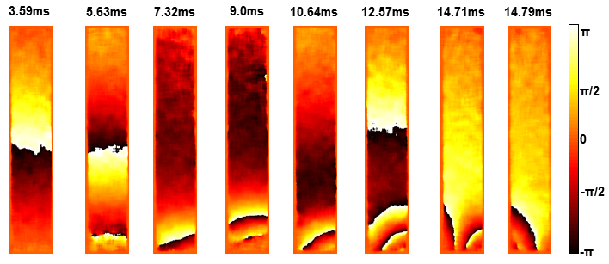
- Travelling wave at the ABH termination

Conclusion
This paper presents a high-speed digital holographic method to study travelling acoustic waves. We have presented the case of a wave front propagating after a shock and the case of a transient acoustic wave interacting with an acoustic black hole.

Acknowledgment
The author thanks Julien Poittevin, François Gautier, and Charles Pézerat, from LAUM, for their very efficient and friendly contribution to this work. This study is part of the Chair program VIBROLEG (Vibroacoustics of Lightweight structures) supported by IRT Jules Verne (French Institute in Research and Technology in Advanced Manufacturing Technologies for Composite, Metallic and Hybrid Structures). The authors wish to associate the industrial and academic partners of this project; respectively Airbus, Alstom Power, Bureau Veritas, CETIM, Daher, DCNS Research, STX and University of Maine in France.

References
- L.E. Drain, The laser Doppler technique, Chichester, New York, Wiley, 1980.
- 2. C.B. Scruby and L.E. Drain, Laser-ultrasonics: techniques and applications, Bristol, UK, Adam Hilger, 1990.
- J.-P. Monchalin, “Progress towards the application of laser-ultrasonics in industry,” In: D.O. Thompson & D.E. Chimenti, editors, Review of progress in quantitative nondestructive evaluation, Vol. 12. p. 495, New York: Plenum (1993).
- P. Castellini, G.M. Revel, and E.P. Tomasini, “Laser doppler vibrometry: a review of advances and applications,” Shock. Vib. Dig. 30, 443-456 (1998).
- W. MacPherson, M. Reeves, D. Towers, A. Moore, J. Jones, M. Dale, and C. Edwards, "Multipoint laser vibrometer for modal analysis," Appl. Opt. 46, 3126-3132 (2007).
- K. Sun, L. Yuan, Z. Shen, Z. Xu, Q. Zhu, X. Ni, and J. Lu, "Scanning laser-line source technique for non destructive evaluation of cracks in human teeth," Appl. Opt. 53, 2366-2374 (2014).
- M. Connelly, P. Szecówka, R. Jallapuram, S. Martin, V. Toal, and M. Whelan, "Multipoint laser Doppler vibrometry using holographic optical elements and a CMOS digital camera," Opt. Lett. 33, 330-332 (2008).
- Y. Fu, M. Guo, and P. Phua, "Multipoint laser Doppler vibrometry with single detector: principles, implementations, and signal analyses," Appl. Opt. 50, 1280-1288 (2011).
- Y. Fu, M. Guo, and P. Phua, "Spatially encoded multibeam laser Doppler vibrometry using a single photodetector," Opt. Lett. 35, 1356-1358 (2010).
- P. Picart, J. Leval, D. Mounier, and S. Gougeon, “Time averaged digital holography”, Opt. Lett. 28, 1900-1902 (2003).
- J. Poittevin, P. Picart, C. Faure, F. Gautier, and C. Pézerat, "Multi-point vibrometer based on high-speed digital in-line holography," Appl. Opt. 54, 3185-3196 (2015).

